**Azure data factory and its copy activity:-**

Azure Data Factory is a cloud-based data integration service that allows you to create, schedule, and orchestrate data pipelines to move and transform data from various sources to different destinations. It provides a platform for building hybrid data integration solutions that connect data across cloud and on-premises environments.

One of the key components of Azure Data Factory is Copy Activity, which is used to move data between different data stores. Here's how you can execute and explain Copy Activity in Azure Data Factory:

**1.Create a Data Factory:** First, you need to create an Azure Data Factory instance in the Azure portal. This involves providing basic information like subscription, resource group, region, and name for your data factory.

**2.Create Linked Services:** Linked Services are connections to external data sources or destinations. You'll need to create linked services for the source and destination data stores you want to work with. For example, if you're copying data from an Azure SQL Database to Azure Blob Storage, you'll need to create linked services for both databases.

**3.Create Datasets:** Datasets represent the data structures within your data stores. You'll define datasets for the source and destination data, specifying the format, schema, and location of the data. This helps Data Factory understand the structure of the data it's working with.

**4.Create Pipelines**: Pipelines are the workflows that define the data movement and transformation tasks. You'll create a new pipeline and add Copy Activity to it. Within the Copy Activity, you'll specify the source dataset, destination dataset, and any transformations or mappings required.

**5.Configure Copy Activity:** In the Copy Activity settings, you'll specify details like the source and destination linked services, the source and destination datasets, any data transformations or mappings, and options for copying data (e.g., incremental copy, parallel copy).

**6.Debug and Execute Pipeline**: Before deploying your pipeline to production, you can debug and test it within the Azure Data Factory interface. This allows you to verify that the data movement and transformations are working as expected. Once you're satisfied with the pipeline, you can deploy and schedule it to run automatically according to your desired frequency.

Now, let's explain some key concepts and features of Azure Data Factory Copy Activity:

* **Data Movement:** Copy Activity supports moving data between various data sources and destinations, including Azure Blob Storage, Azure SQL Database, Azure Data Lake Storage, on-premises databases, and more. It provides built-in connectors for many common data sources and destinations, making it easy to integrate with different systems.
* **Data Transformation:** Copy Activity allows you to perform basic transformations on the data during the copy process, such as column mapping, data type conversion, and filtering. You can also use Azure Data Factory's data flow feature for more advanced data transformations and processing.
* **Performance and Scalability:** Copy Activity is designed for high performance and scalability, with features like parallel data transfer and automatic retry mechanisms to handle large volumes of data and ensure data integrity.
* **Monitoring and Logging**: Azure Data Factory provides monitoring and logging capabilities to track the execution of pipelines and activities, monitor data movement performance, and troubleshoot any issues that arise during the copy process.

Overall, Copy Activity in Azure Data Factory is a powerful tool for building data integration and ETL (extract, transform, load) pipelines, allowing you to move and transform data efficiently between different data sources and destinations in the cloud and on-premises environments.

**Copy Activity:- Blob to Blob**

**Create data storage account:-**

* Create a hexaazureblob1 account
* Create two container in it input and output
* Upload a csv file in the input container biba.csv.

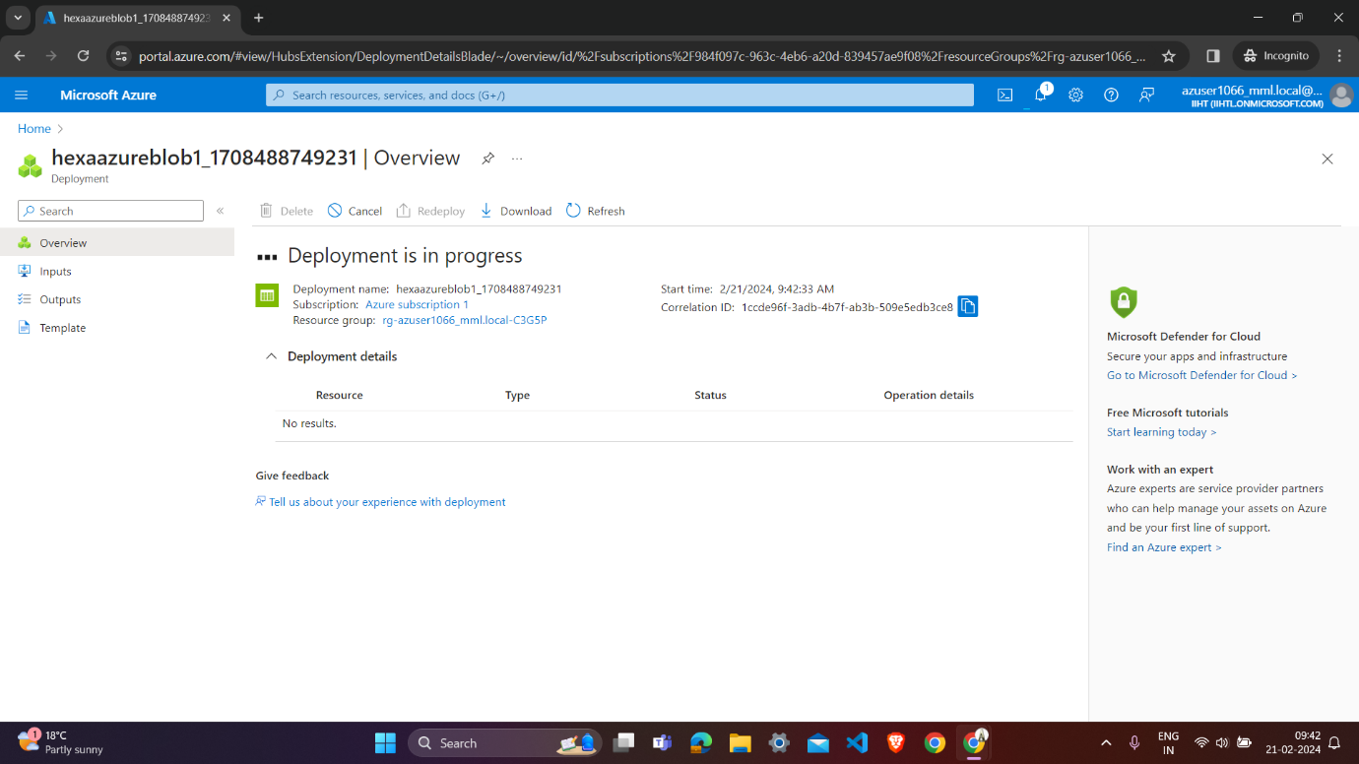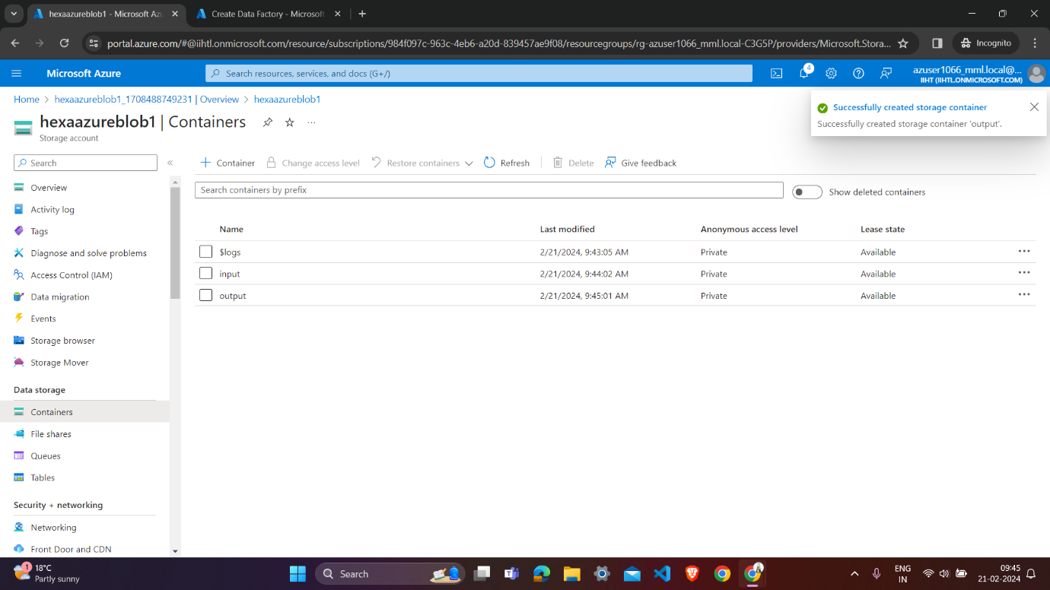

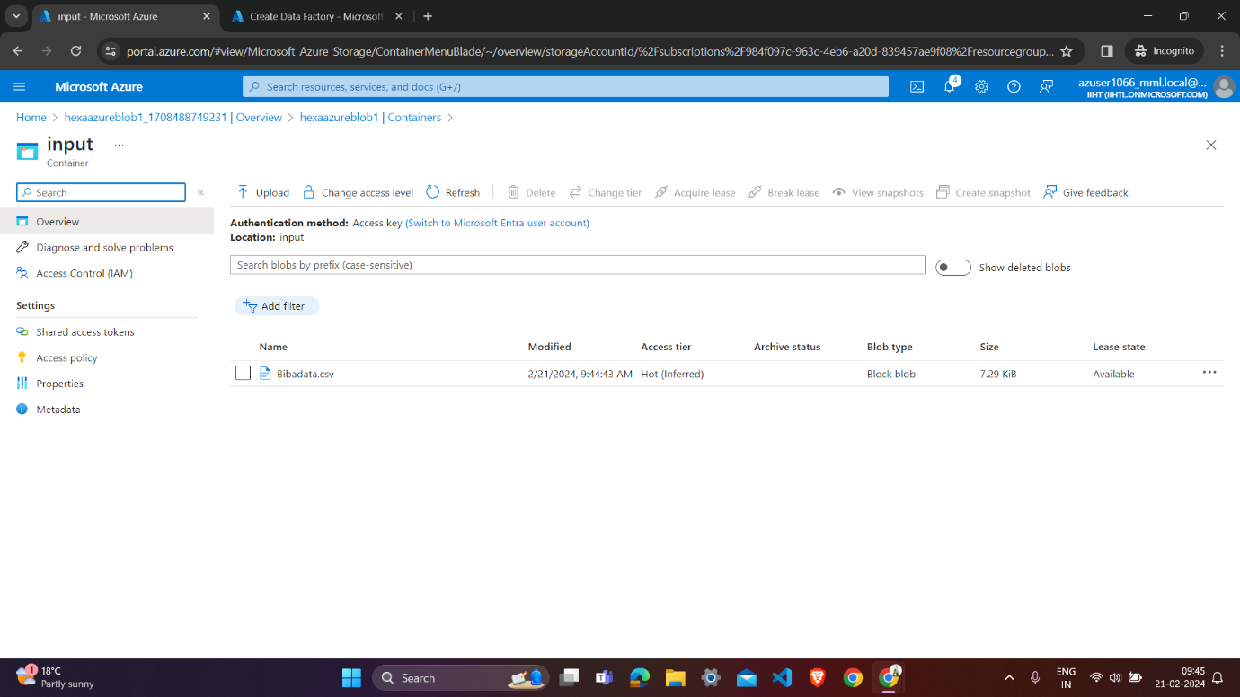

**Create a data factory name hexa1066:-**

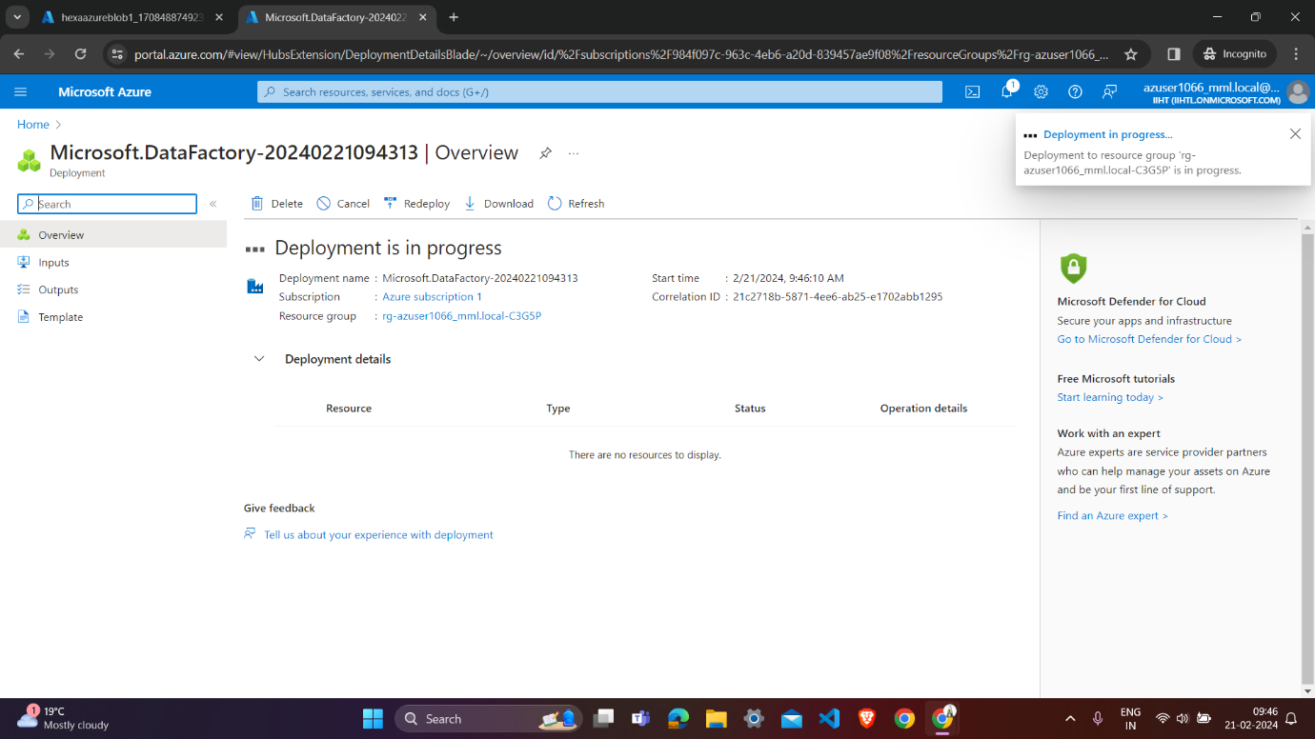

**Launch Azure Data factory studio:-**

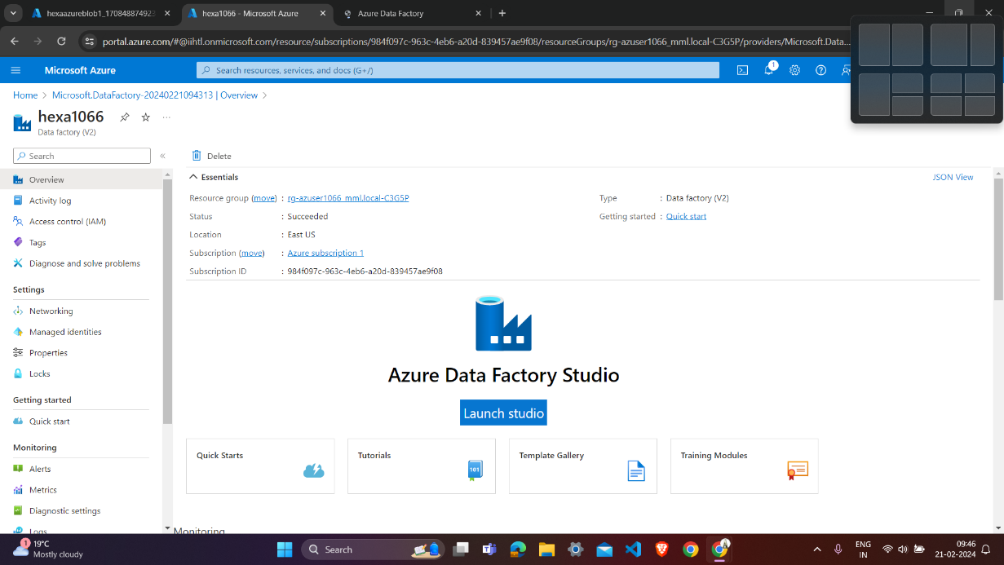

**Azure Data factory launching:-**

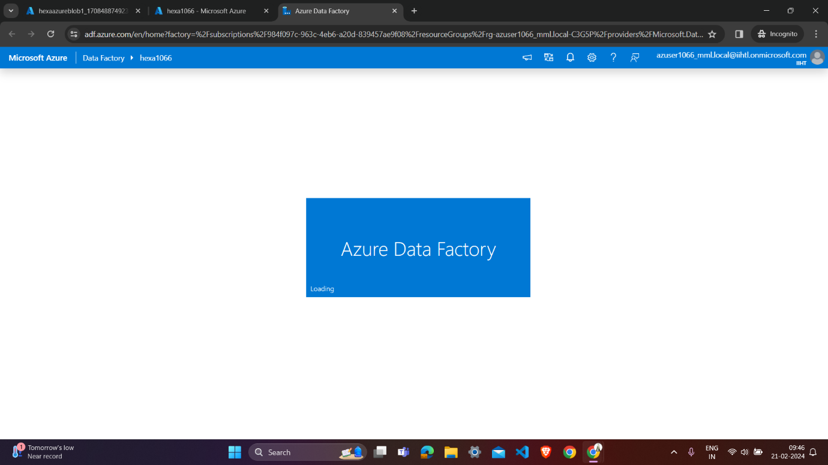

**Create built-in copy task:-**

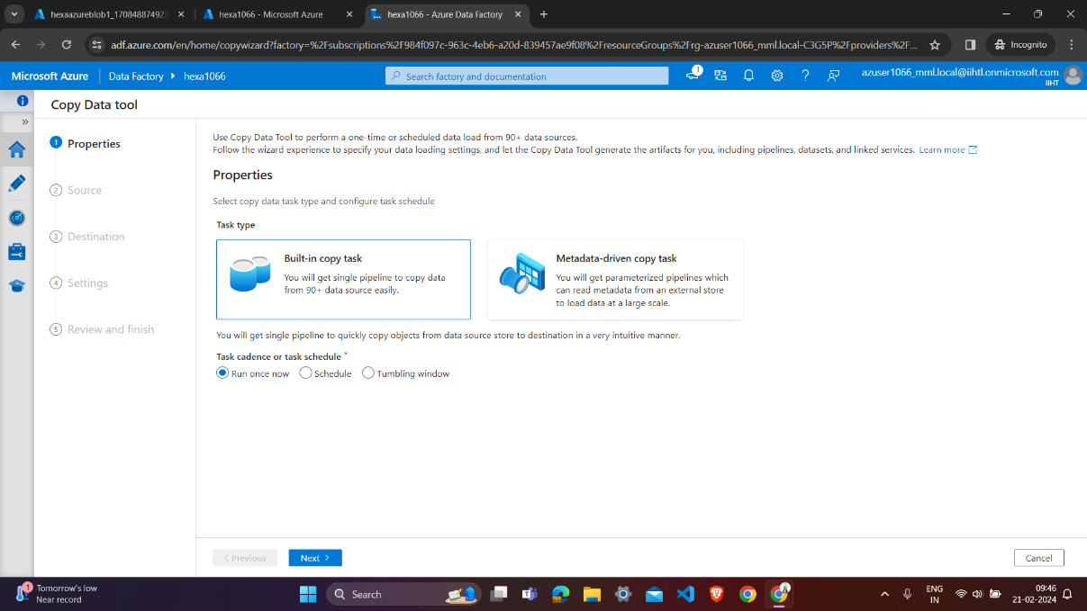

**Enter source type (azure blob storage) and create new connection:-**

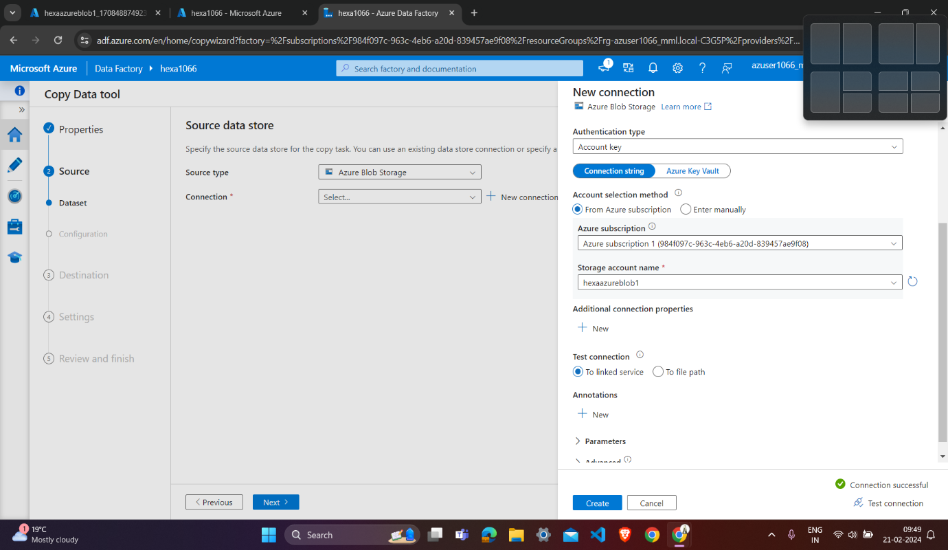

**Enter the source and destination detail :-**

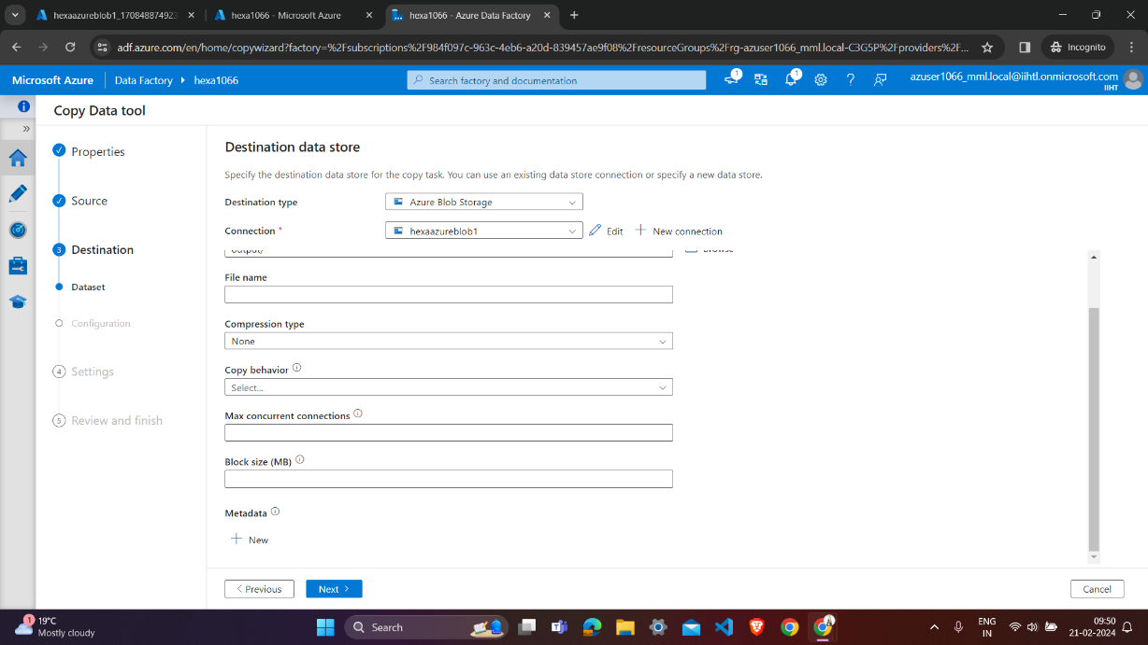**on**

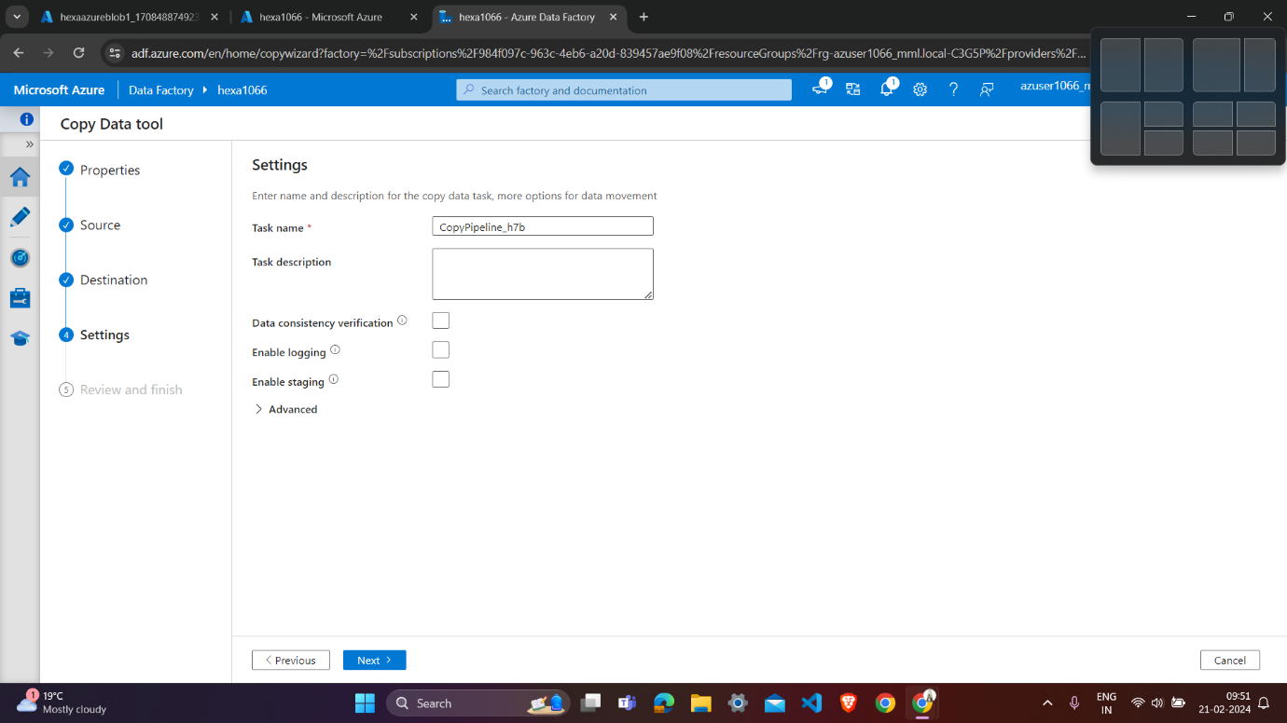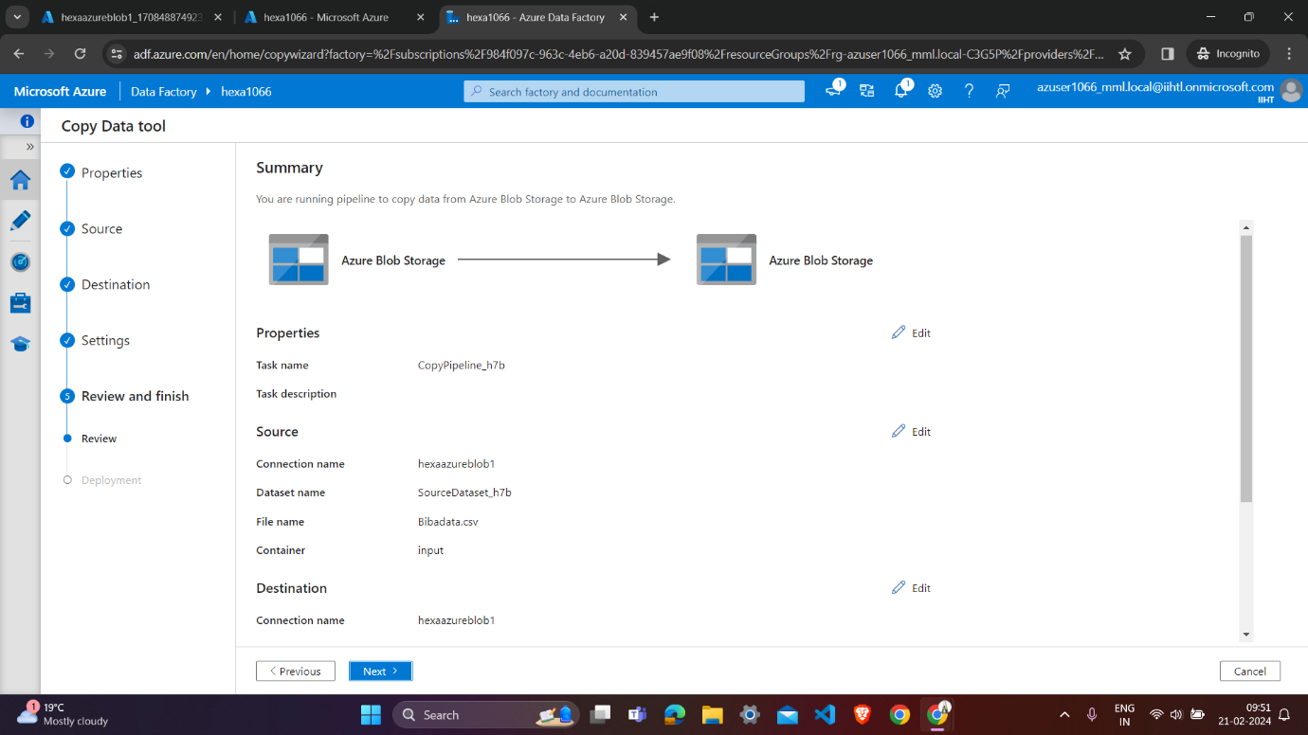

**Finish Deployment:-**

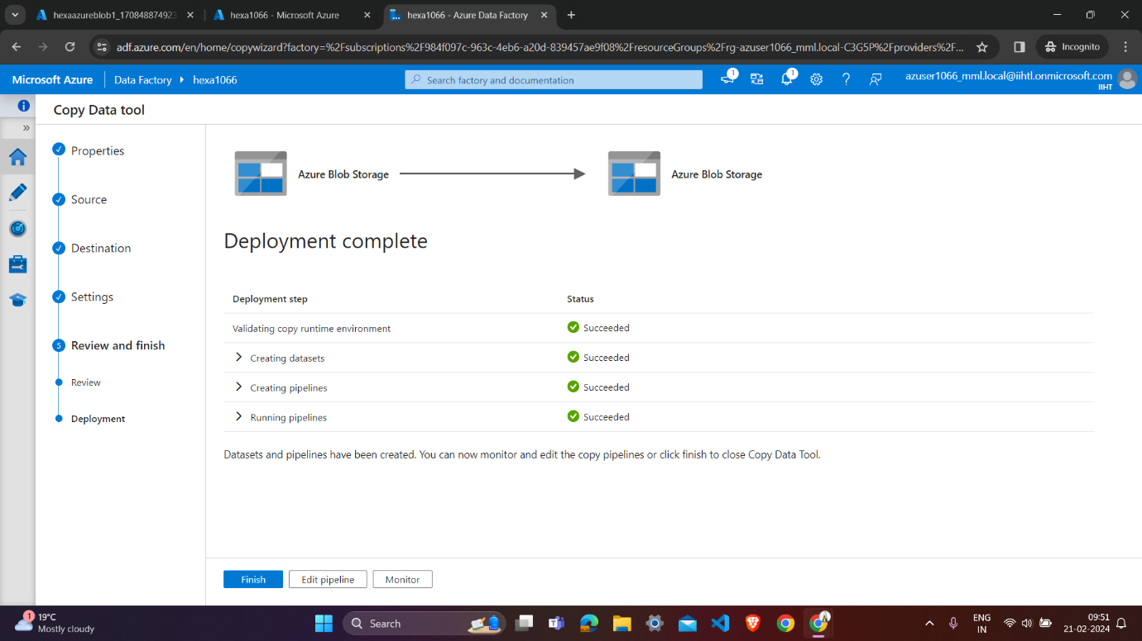

**Input file we upload biba.csv:-**

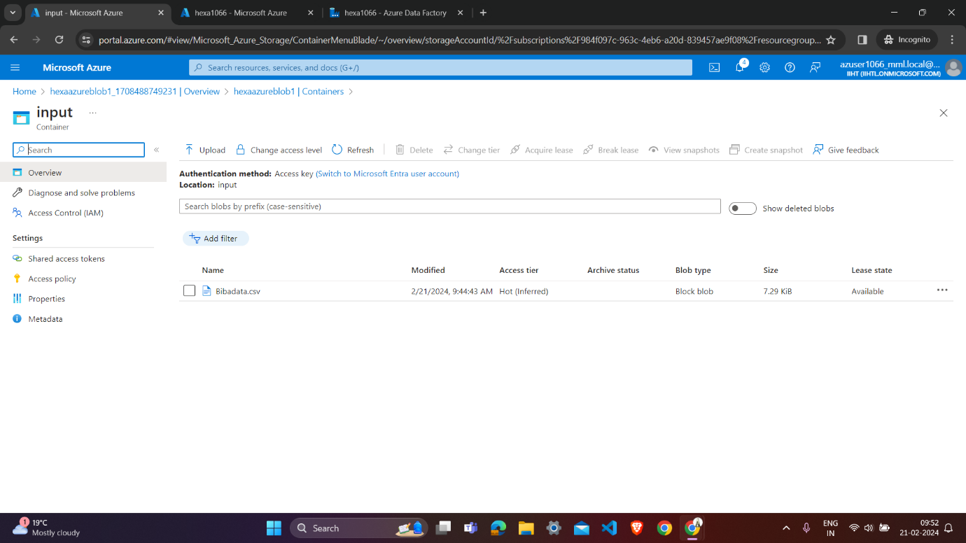

**Output container have copy of input biba.csv file:-**

